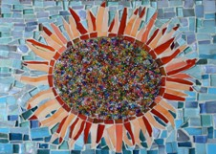
Making
Mosaics

Y

ou can learn how to cut and place mosaic pieces in a few hours, while you create a design that makes you happy!
Take a short workshop to find out the basics. You will make a small piece (trivets work well for this) that you can take home with you and use. You can use any mosaics you like from my large collection, as well as glue and grout. There will be lots of books to look at if you want ideas.
First session: Look at different types of mosaic materials, learn how to cut and place tiles, figure out what you want to make, make your first piece of mosaic art.
Second session: Learn about grouting, and grout your trivet, or finish up your design. You can take grout home with you if you need to, so you can finish your trivet later. (Glue needs at least a day or two to set before you can grout your piece.)
Cost: First two sessions, 4 hours total: $60. After that, you can continue to use the space and materials for $20 per 2.5-hour session if you bring your own materials, or $30 if you use mine.
Class size: Maximum of four. Very personalized attention.
Location: Cheerful sunny studio in West Medford, MA. The space is on the second floor and is only accessible by stairs.
How to sign up: Email Susan Altman at GlassAndGrout[at]gmail[dot]com.

